Source Code for the program and then the output of the source code is:

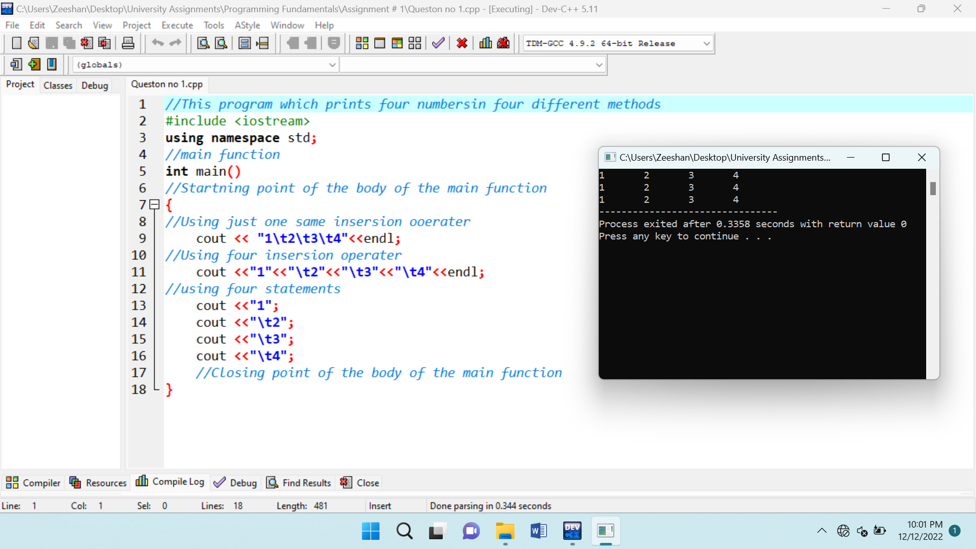

Source Code for the program and then the output of the source code is:

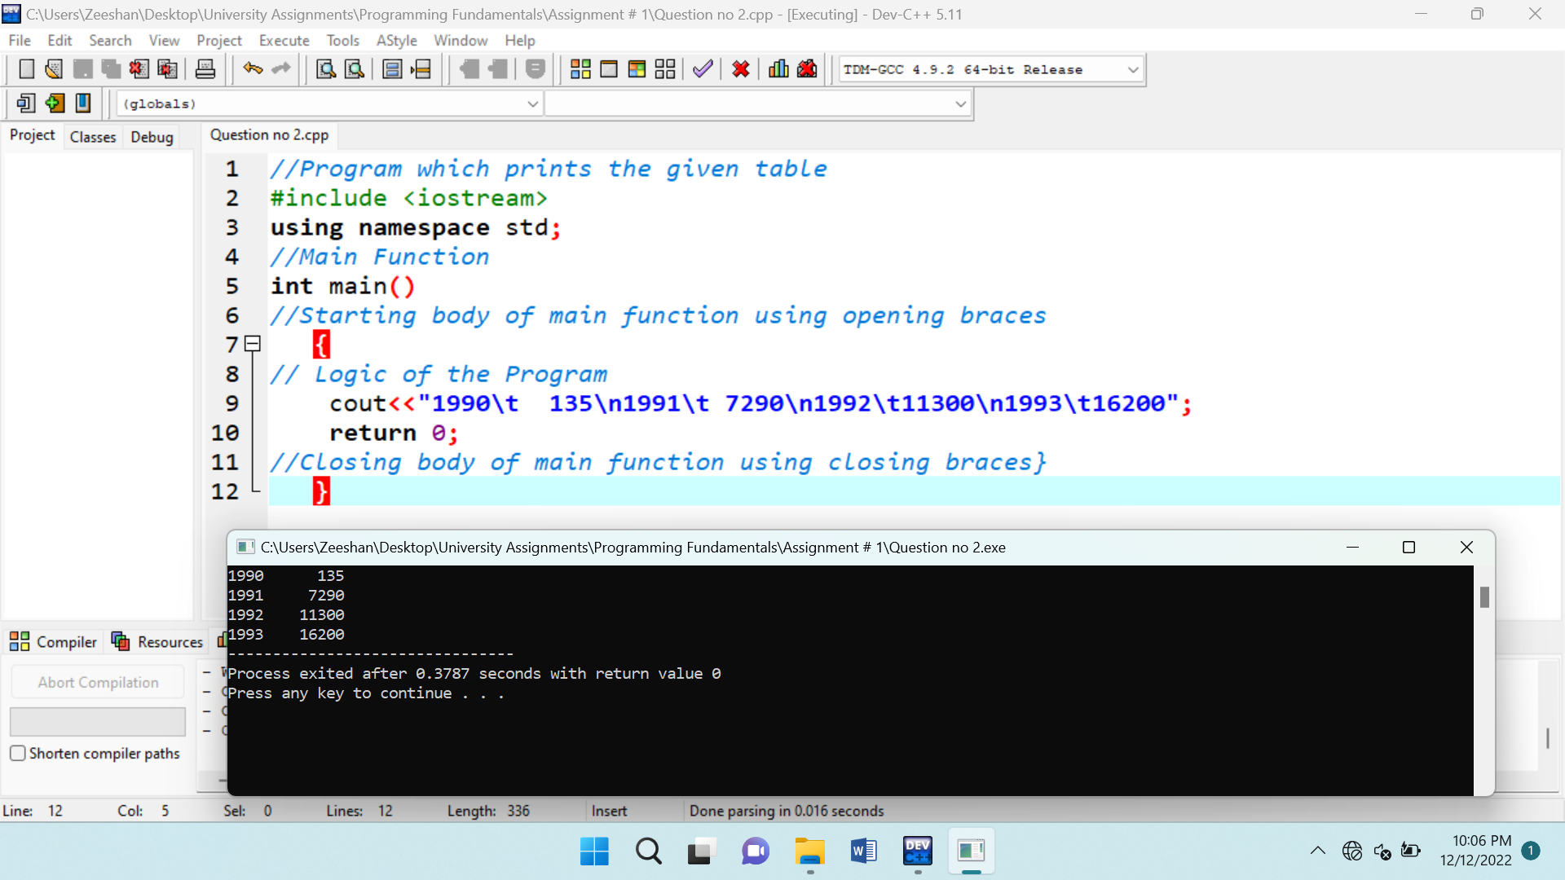

Source Code for the program and then the output of the source code is:

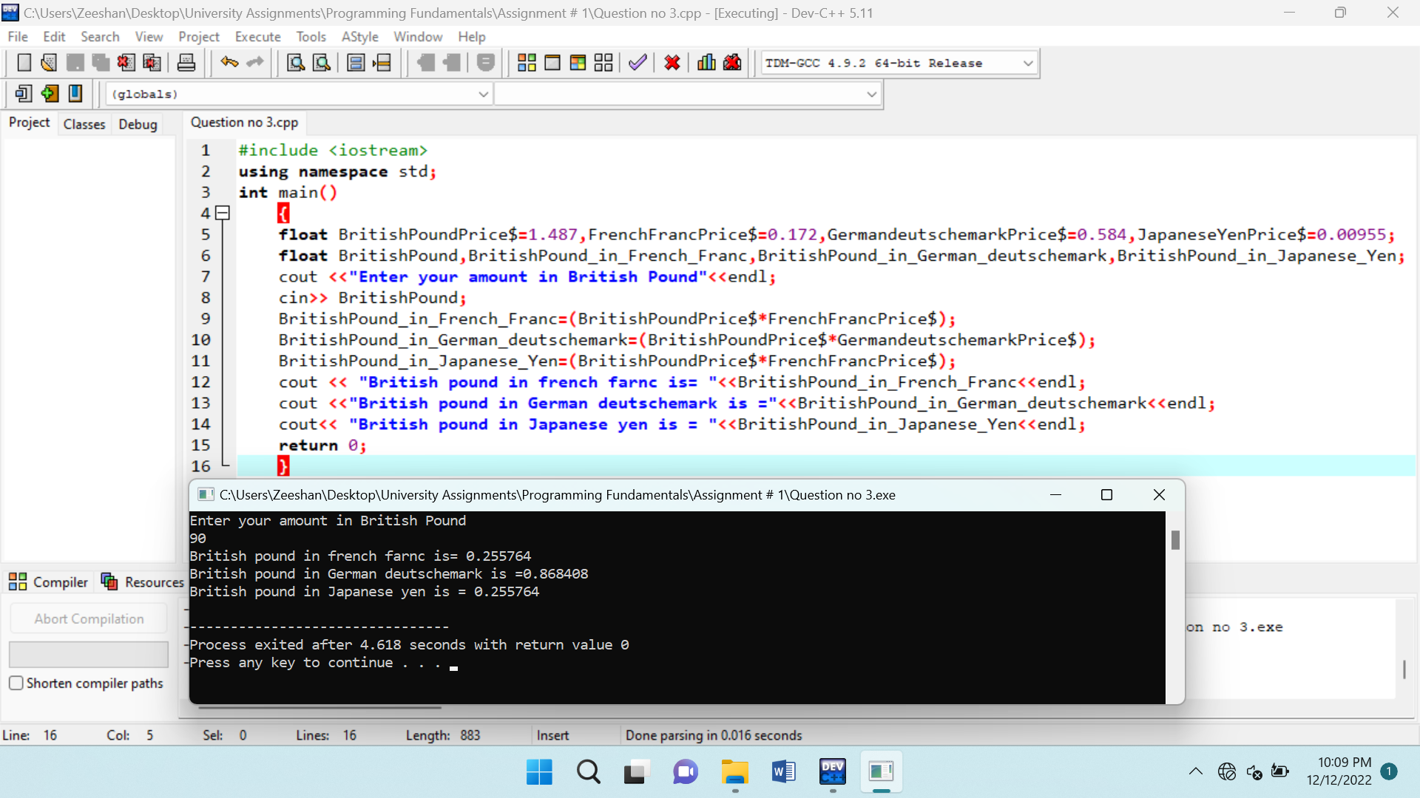

Source Code for the program and then the output of the source code is:

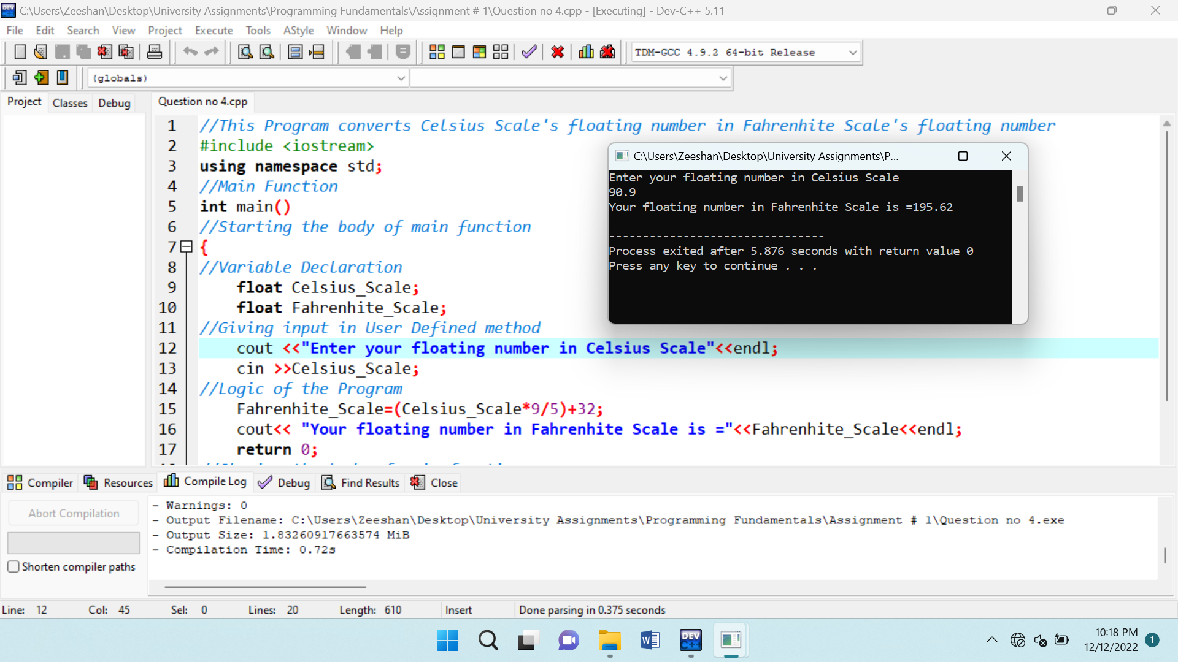

Source Code for the program and then the output of the source code is:

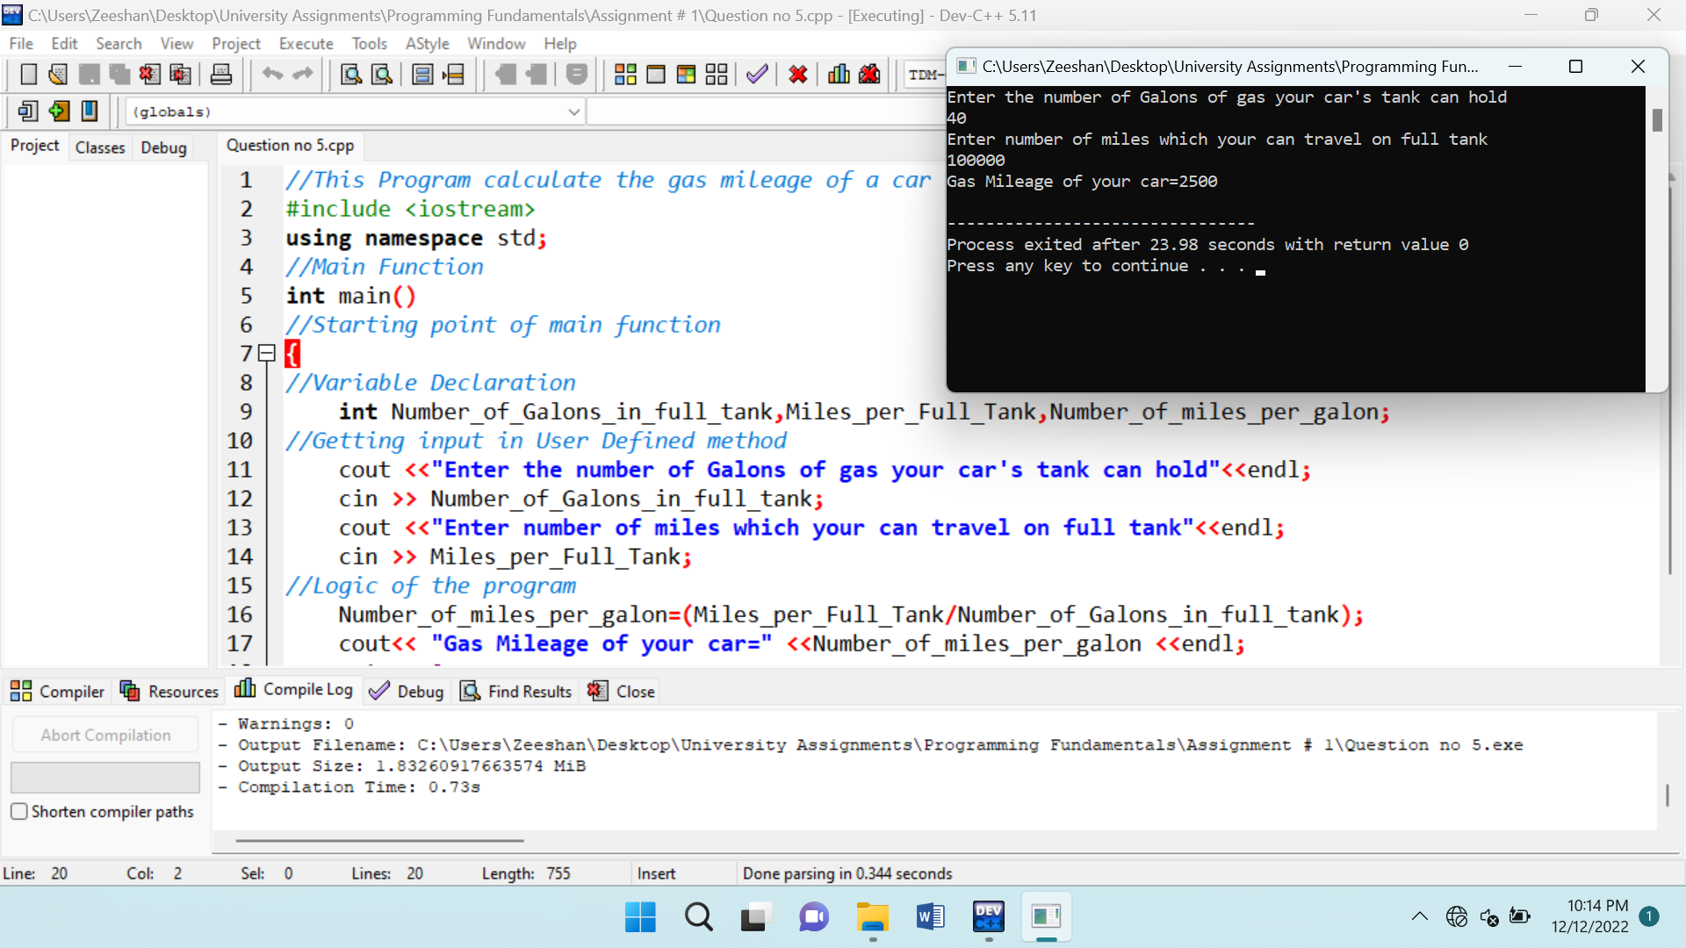

Source Code for the program and then the output of the source code is:

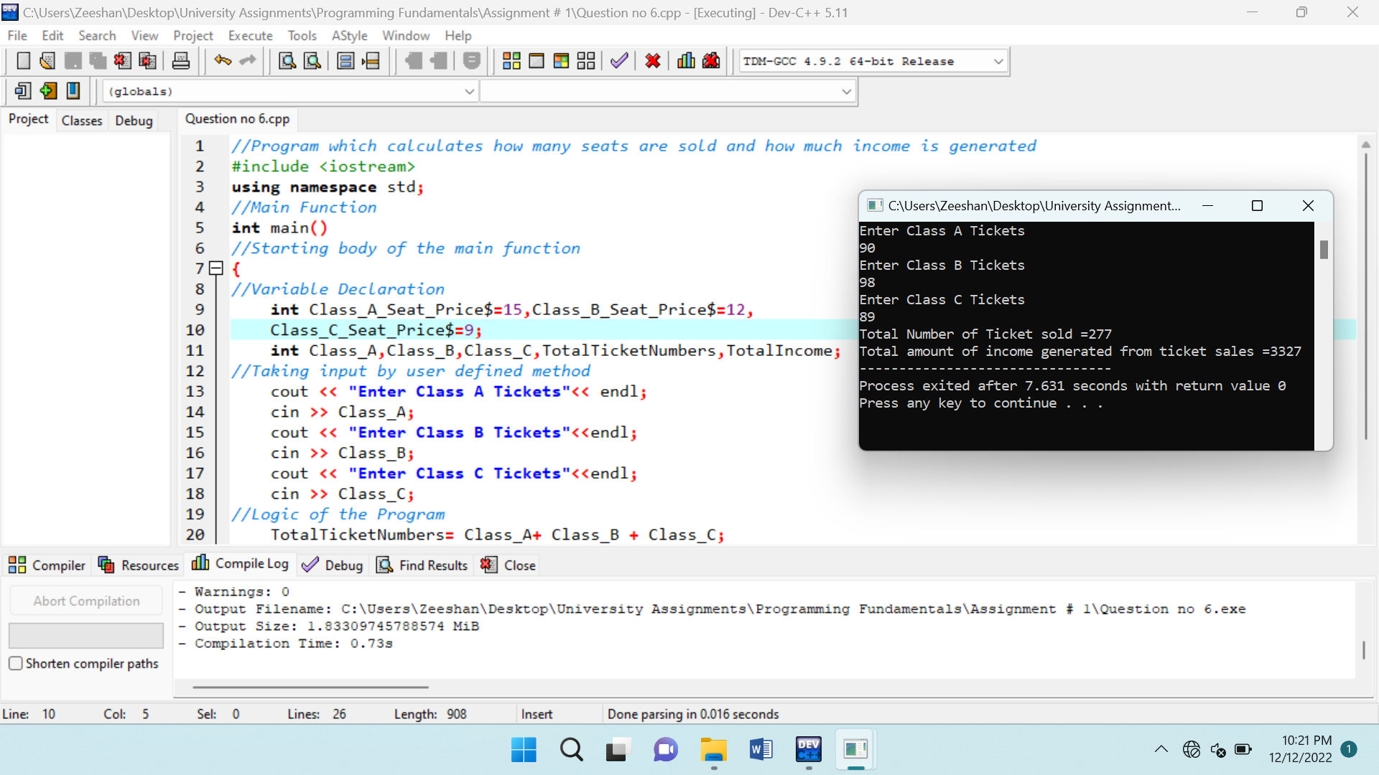

Source Code for the program and then the output of the source code is:

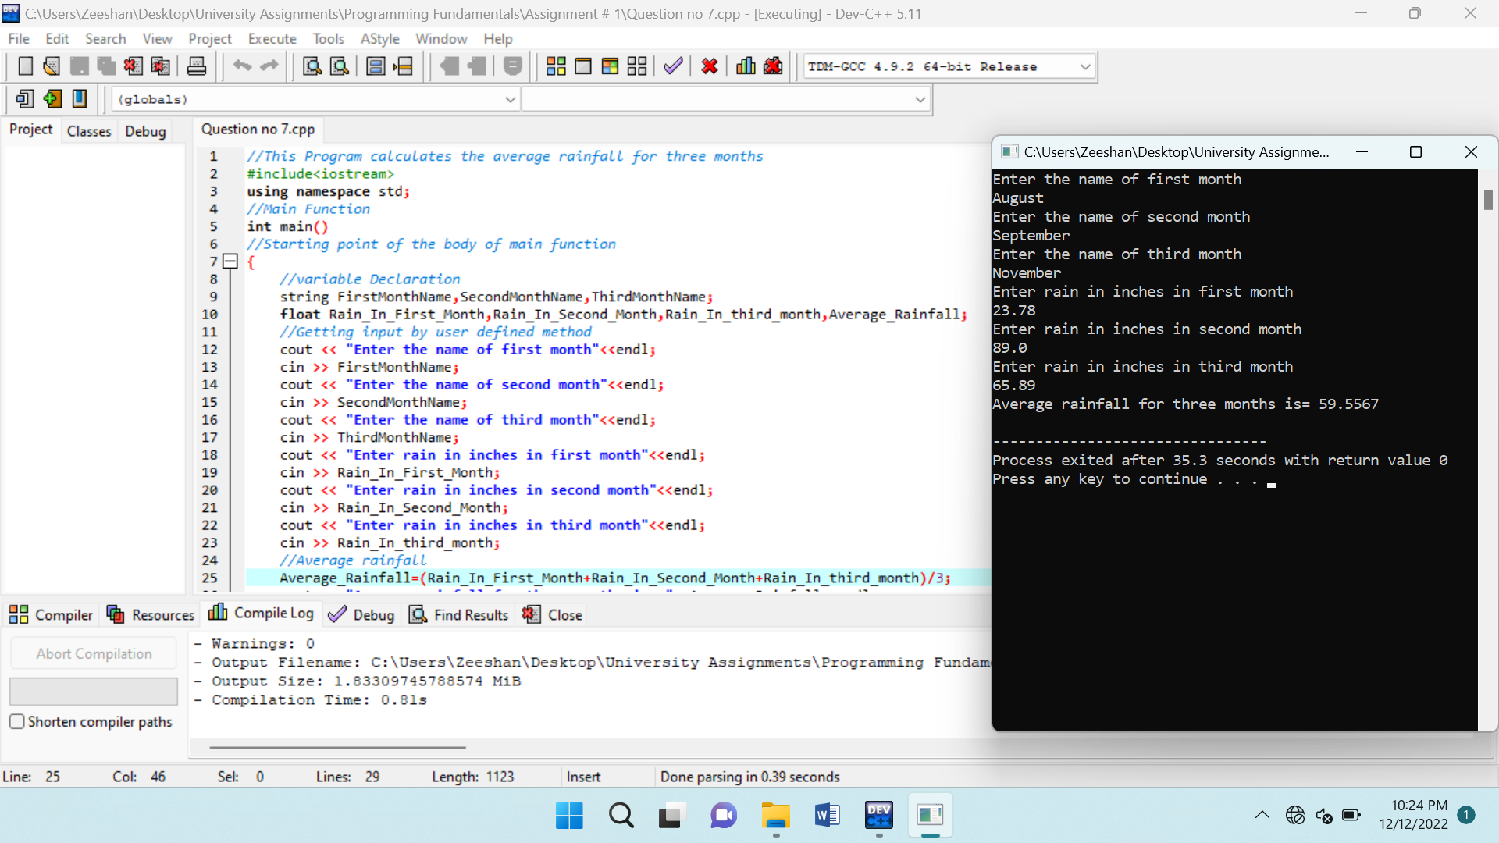

Source Code for the program and then the output of the source code is:

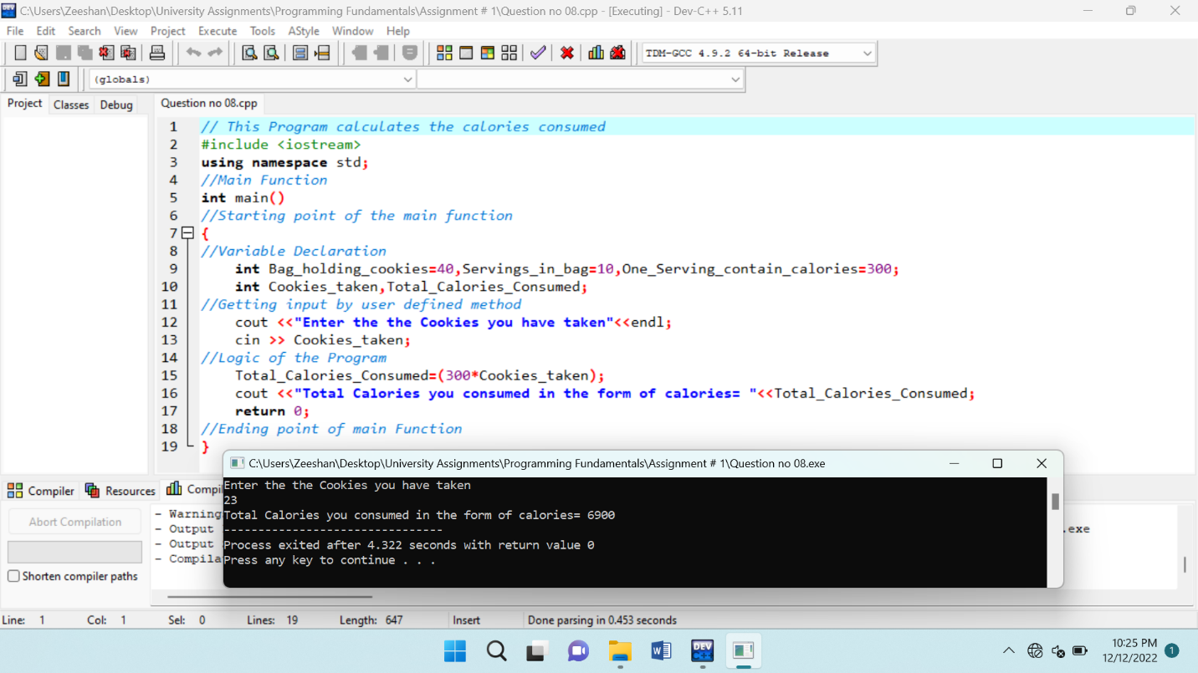

Source Code for the program and then the output of the source code is:

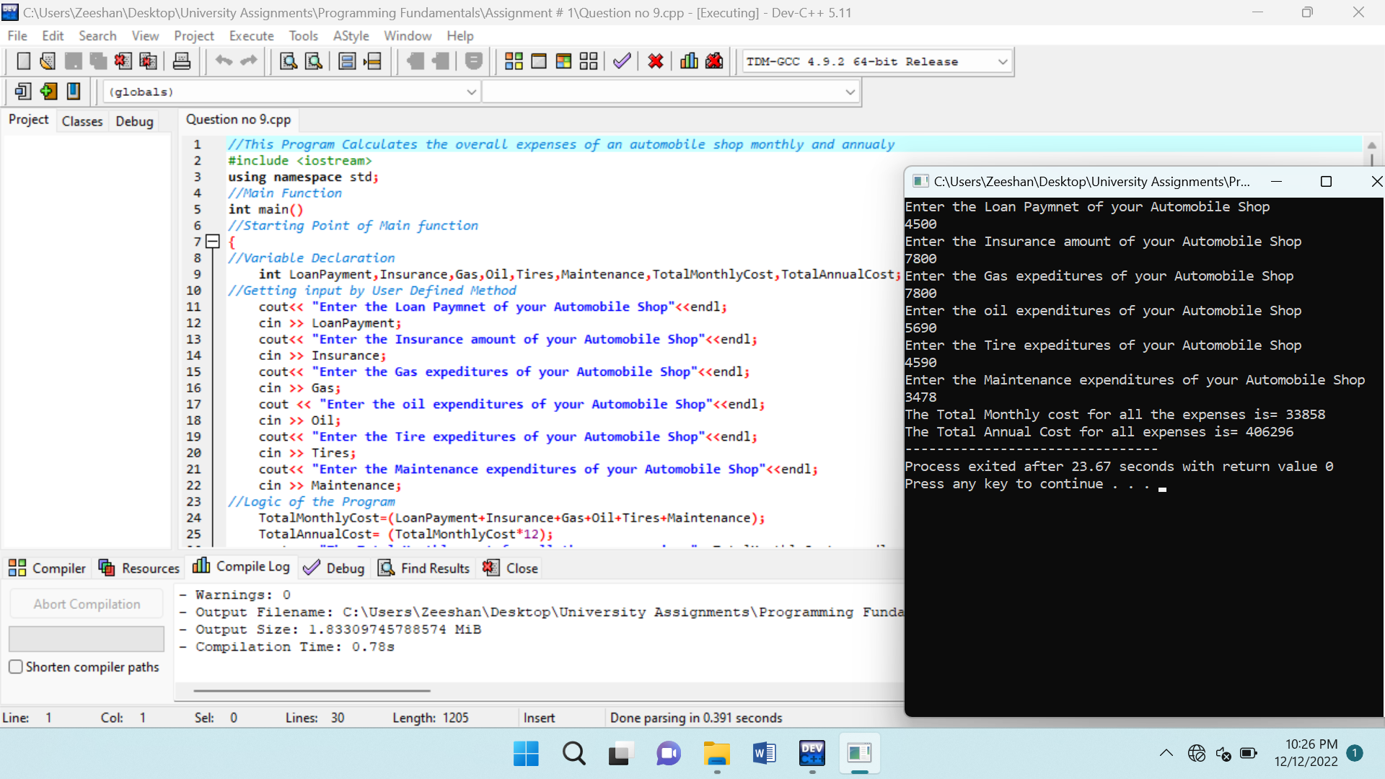

Source Code for the program is:

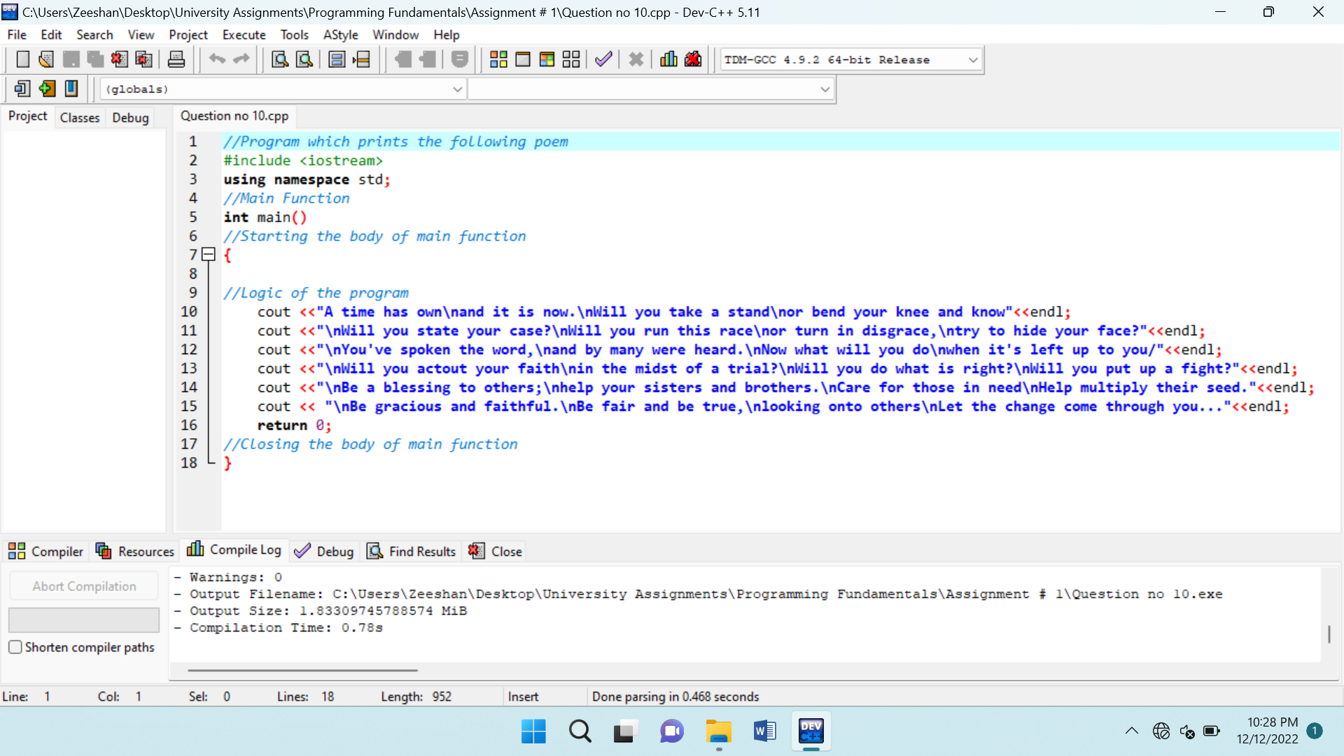

The output of the source code is:

